1. Add 5 games to the database. Give each document the following properties: name, genre, rating (out of 100)



1. Write a query that returns all the games.

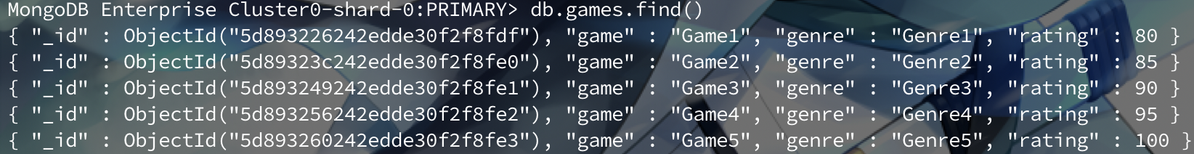

1. Write a query to find one of your games by name without using limit(). Use the findOne method.

1. Write a query that returns the 3 highest rated games.

1. Update your two favorite games to have two achievements called ‘Game Master’ and ‘Speed Demon’, each under a single key. Show two ways to do this. Do the first using update() and do the second using save().

1. Write a query that returns all the games that have both the ‘Game Master’ and the ‘Speed Demon’ achievements.

1. Write a query that returns only games that have achievements.

